

**Bangladesh University of Business & Technology (BUBT)**

Project Report

On

**Design a circuit that would give a voltage output which is two third of input.**

**DEPARTMENT OF ELECTRICAL & ELECTRONIC ENGINEERING**

**Faculty of Engineering & Applied Science**

**Submitted To**

**Sabbir Hossain**

Teaching Assistant

**Department of EEE, BUBT**

## Submitted By

|  |  |  |
| --- | --- | --- |
| **Name** | **ID** | **Intake/Section** |
| Tasmin Jahan | 20212208021 | 32/1 |
| Soyod Rahabar-A-Islam | 20212208022 | 32/1 |
| Abdullah Al Sayem | 20212208023 | 32/1 |
| Mamun Or Rashid | 20212208025 | 32/1 |
| Md. Munna Hossain | 20212208029 | 32/1 |

**ACKNOWLEDGEMENT**

We express our gratitude and sincere thanks to our teacher **Sabbir Hossain**, Department of Electrical and Electronics Engineering for his gracious efforts and keen pursuit, which has remained as a valuable asset for the successful of our project report. His dynamism and diligent enthusiasm have been highly instrumental in keeping our spirits high. His flawless and forthright suggestions blended with an innate intelligent application have crowned our task with success. We truly appreciate and value his esteemed guidance and encouragement from the beginning to the end of this thesis. We are indebted to him for having helped me shape the problem and providing insights towards the solution.

At last but not the least I am highly thankful to the THE ALMIGHTY, who has given me the courage and wisdom throughout this whole journey.

**THEORY**

* In a series circuit the current is same through all of the circuit elements.
* In a series circuit, The equivalent Resistance of the circuit is, $R_{equivalent}$ = R1+R2+…Rn (Value of Resistors)
* By Ohm's Law, The current is, I= Vsupply/ $R_{equivalent}$

**Step for Verification**

1. Firstly, open the simulation software “ Proteus 8 Pro”.
2. Then Click on Schematic Capture.
3. Secondly, pick some required parameters like- DC Voltage Source, Resistor, Load & DC voltmeters from Proteus 8 Pro.
4. Now connect required parameters and make a series circuit.
5. Calculate Voltage drop across each Resistor from the verification.

**Verification**

1. 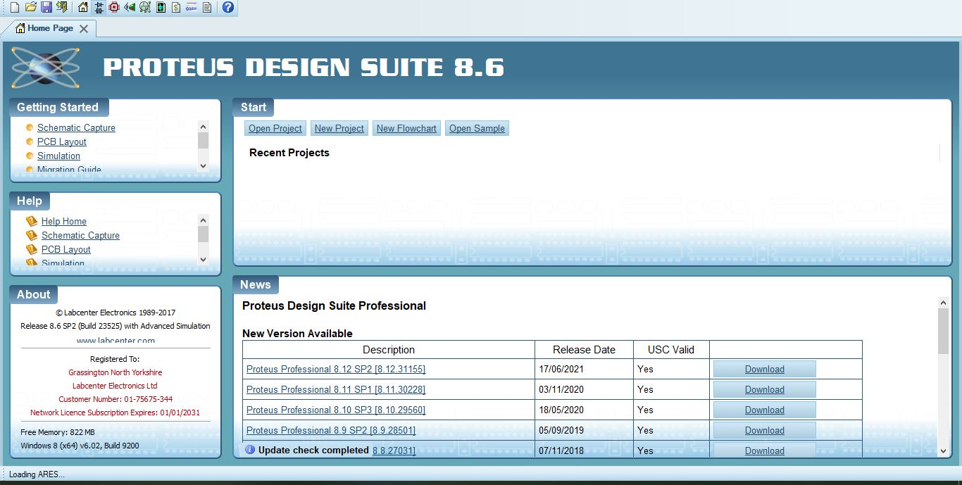Firstly, We open the simulation software on PC/LAPTOP, Then Click on Schematic Capture.
2. Secondly, Click ”P” On your keyboard & Pick required parameters like-
3. DC Supply
4. Resistor
5. Load (Lamp)
6. 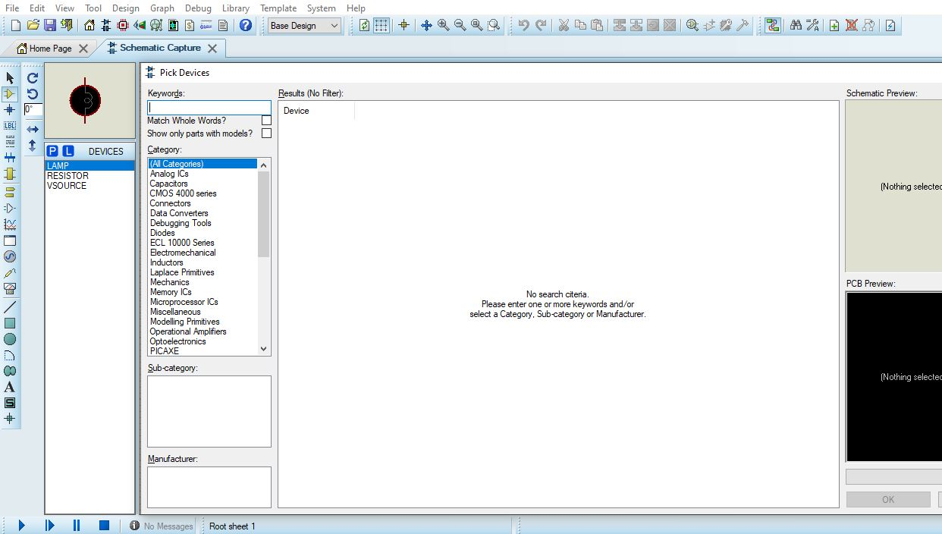DC Voltmeter
7. Now, Set the DC supply to 30V.
8. Set the value of Resistor to 10 Ohm.
9. Then, Set Load (Lamp) internal barrier at 20 Ohm.
10. Now, Construct the circuit as shown as Figure below.

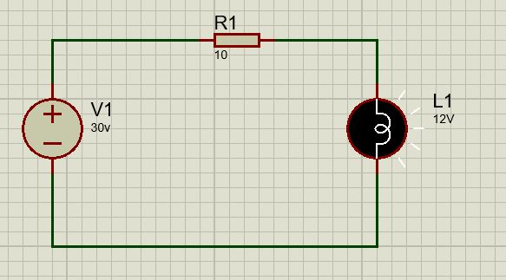

1. Now, Connect Voltmeters across the resistor R1 and Load (12 V) .
2. Turn on the DC Supply 30V.
3. Now, We can see that the voltage drop across resistor & lamp is 10 V and 20 V. (Shown as Figure below)

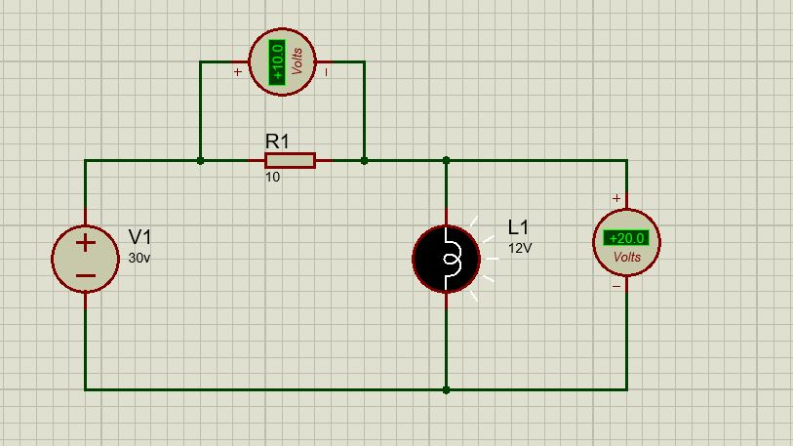

**DATA TABLE**

|  |  |  |  |
| --- | --- | --- | --- |
| **Nominal values of Resistance**  **(ohm)** | **Supply Voltage**  **(V)** | **Measured voltage across each Resistor (V)** | **Calculated Voltage using VDR (V)** |
| 10 | 30 | 10 | 10 |
| 20 | 30 | 20 | 20 |

**Result & Discussion**

The voltage divider rule States that the voltage across an element or across a series combination of elements in a series circuit is equal to resistance/ reactance of the element divided by total resistance/impedance of the series circuit and multiplied by the total impressed voltage. For the elements of these figure-

**V1=R1*E/ Req**

**V2 or VL=R2*E/Req**

**CONCLUSION**

In the experiment, We can hardly say that The circuit is given output voltage that is two third of input voltage.

In summary, this lab has shown that although the voltage of a DC source as a function of current is constant. Another thing that can be concluded from this experiment is how voltage can divide by different type of barriers in a series circuit. Fir a voltage divider circuit, the voltage across each element is proportional to the resistance of that element divided by the total resistance in series.